Lesson 3 Demo 7: Push an Image to a Registry

This section will guide you to:

* Push an image to a registry

**Note:** Please ensure you successfully execute all the previous demos of this lesson.

**Step 1**: Copy an image from Docker Hub to your registry

* Pull the ubuntu image using the command:

*sudo docker pull nginx*

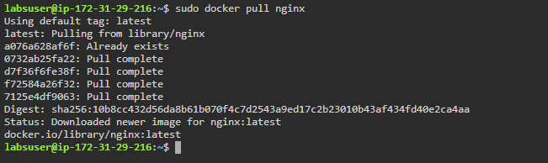

* Tag the image using the command:

*sudo docker tag nginx localhost:5000/nginx*

* Push the image to the local registry using the command:

*sudo docker push localhost:5000/nginx*

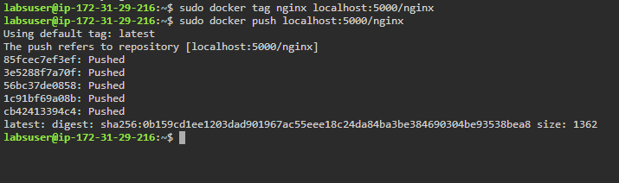

* Remove the locally cached images using the command:

*sudo docker image remove nginx*

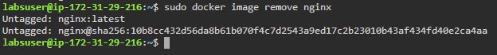

* Pull the *localhost:5000/nginx* image from the local registry using the command:

*sudo docker pull localhost:5000/nginx*

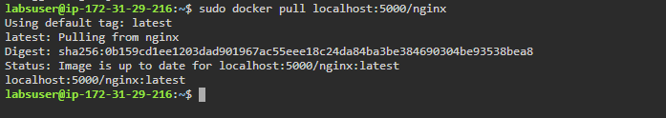

**Step 2**: Stop the running registry container

* List all the running containers to check the registry container

*sudo docker ps*

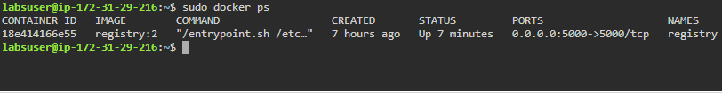

* Stop the registry container using the following command:

*sudo docker container stop registry*

